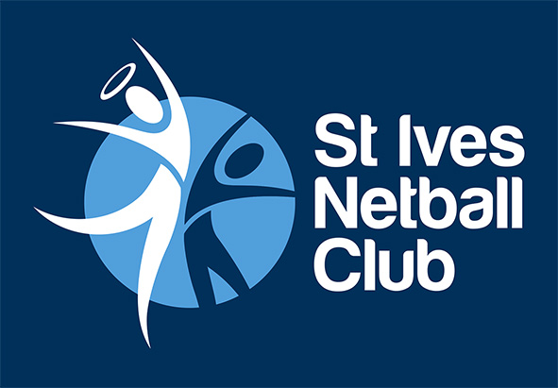 | Policy  Inclusion at St Ives Netball Club

Purpose
The purpose of this policy is to ensure our club is welcoming and we will seek to include members from all areas of our community.
Scope
This policy applies to all people who register to play or volunteer with St Ives Netball Club.
Policy
At all times and in all situations, our club will take reasonable steps to identify and eliminate unlawful direct, indirect and systemic discrimination from structures and practices and ensure that all members are afforded reasonable opportunity to participate in and gain access to Club activities and services.
- People with disability
  - Where possible, we will include people with disability in our teams and club. We will make reasonable adaptations to enable participation.
- People from diverse cultures
  - We will support and respect people from diverse cultures and religions to participate in our club. Where possible, we will accommodate requests for flexibility (including modifications to uniforms).
- Sexual Preference
  - All people, regardless of their sexual preference, are welcome at our club. We strive to provide a safe environment for participation and will take action over any homophobic behaviour.
Governance
This policy will be regularly evaluated and revised to maintain relevant continuous improvement in Club programs, services and facilities for people from different backgrounds, cultures and abilities.
Version Control and Change History
Version Number | Approval Date | Approved by | Amendment
1 | 21 November 2016 | Executive Committee

